AWS Custom resource
https://docs.aws.amazon.com/es_es/AWSCloudFormation/latest/UserGuide/template-custom-resources.html
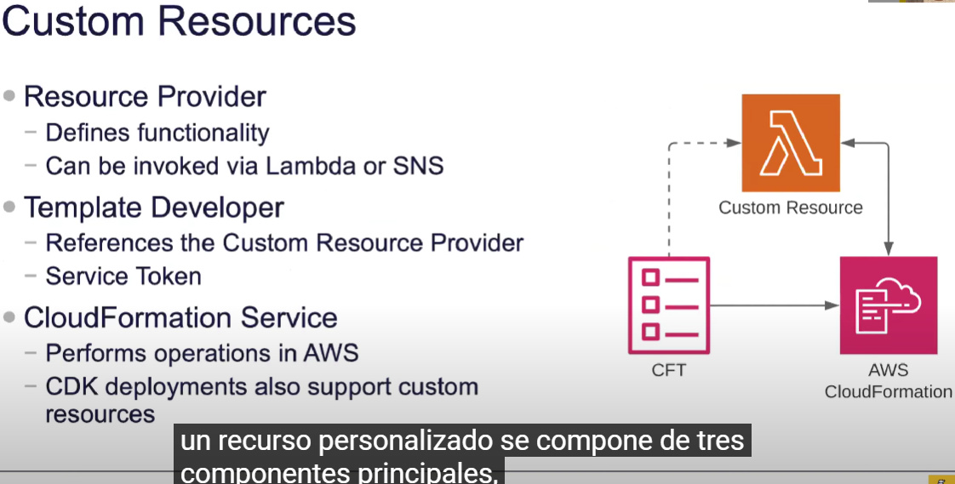
En el primero se definen funcionalidades,
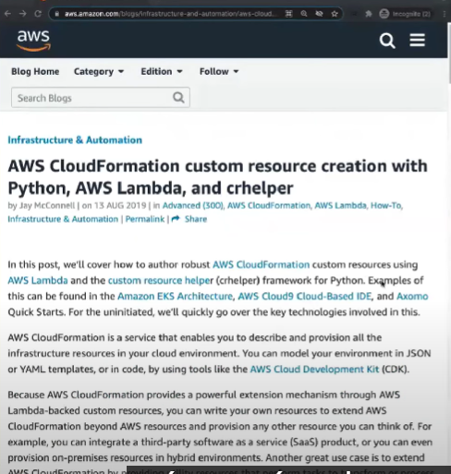
Ejemplo practico:
https://aws.amazon.com/es/blogs/infrastructure-and-automation/aws-cloudformation-custom-resource-creation-with-python-aws-lambda-and-crhelper/

https://repost.aws/es/questions/QUvAaCd6J7To-Fs-eReXMgNg/to-add-an-aws-custom-resource-to-cloudformation-template-and-provide-an-aws-lambda-function

https://www.youtube.com/watch?v=YesBAPBLCfA

#!/usr/bin/env python
# -*- coding: utf-8 -*-

import json
import boto3
import requests

def lambda_handler(event, context):
try:
bucket = event['ResourceProperties']['BucketName']

if event['RequestType'] == 'Delete':
s3 = boto3.resource('s3')
bucket = s3.Bucket(bucket)
for obj in bucket.objects.filter():
s3.Object(bucket.name, obj.key).delete()

sendResponseCfn(event, context, "SUCCESS")
except Exception as e:
print(e)
sendResponseCfn(event, context, "FAILED")

def sendResponseCfn(event, context, responseStatus):
response_body = {'Status': responseStatus,
'Reason': 'Log stream name: ' + context.log_stream_name,
'PhysicalResourceId': context.log_stream_name,
'StackId': event['StackId'],
'RequestId': event['RequestId'],
'LogicalResourceId': event['LogicalResourceId'],
'Data': json.loads("{}")}

requests.put(event['ResponseURL'], data=json.dumps(response_body))

AWSTemplateFormatVersion: '2010-09-09'

Resources:
myBucketResource:
Type: AWS::S3::Bucket
Properties:
BucketName: test-bucket

LambdaUsedToCleanUp:
Type: Custom::cleanupbucket
Properties:
ServiceToken: arn:aws:lambda:us-west-2:XXXXXXXXXXXX:function:lambda_function_name
BucketName: !Ref myBucketResource

